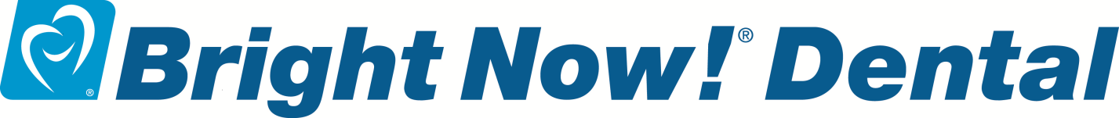

SUPPORTING UNION FAMILIES FOR OVER 40 YEARS
TODAY…TOMORROW…ALWAYS…

APRIL 21, 2020
DENTAL EMERGENCIES

Bright Now! Dental has been here to care for you for over 40 years! And today more than ever, we want you to know we are still here!

As Coronavirus continues to plague us, we at Bright Now! Dental are on a mission to make sure those who have a dental emergency have a dental office to go to.

IF YOU HAVE A DENTAL EMERGENCY, WE ARE HERE TO HELP!
DO NOT GO TO ER OR URGENT CARE!

Many of our dental offices are open for emergencies. No matter who it is – you, your family, patient of record or not -- anyone, everyone – we will take care of you! And as of this week, we are now offering TELEDENTISTRY.

This is a new and innovative platform designed for anyone who is experiencing a dental concern. It is as simple as 1, 2, 3…

Please see the link below to view a short video or go to the website for more information. Or call one of the offices listed below or me directly.

Bright Now! Dental Teledentistry for YOU

www.smilebrands.com/teledentistry

WEEKDAY, WEEKENDS (including Sundays), ALL HOURS INTO THE EVENING.
Office Name | Phone  Number
Bright Now! Dental - Bonney Lake | 253-299-3033
Bright Now! Dental - Federal Way | 253-835-3377
Bright Now! Dental - Gig Harbor | 253-765-5002
Bright Now! Dental - Issaquah | 425-507-1000
Bright Now! Dental - Lynnwood | 425-775-5557
Bright Now! Dental - Maple Valley | 425-578-9152
Bright Now! Dental - Northgate | 206-336-2100
Bright Now! Dental - Olympia/Martin Way | 360-455-9544
Bright Now! Dental - Puyallup | 253-840-0540
Bright Now! Dental - Richland | 509-866-4335
Bright Now! Dental - Spokane | 509-464-2001
Nurani, P.C., Ashifa Nurani, DDS
Be safe and be well,

Carrie Magnuson • Union Account Executive
253-405-4547 • Carrie.Magnuson@smilebrands.com

